# Myctophids Paper Summary

* **Current authors:** Sarah R. Alewijnse, Oliver A. Crimmen, Natalie Cooper, Clive N. Trueman
* **Target journal:** Marine Ecology Progress Series (MEPS)

## Study Premise/Introduction

### Abstract

Myctophids (family Myctophidae) are an important part of the ocean biological carbon pump. Accurately estimating the magnitude of their contribution to the carbon pump requires knowledge of the species’ field metabolic rates; the time-averaged energy expenditure of a free-living organism in its natural habitat. In this study, we calculate Moto, a mass-specific proxy of field metabolic rate derived from otolith d13C, for six species of myctophids from the Scotia Sea (*Electrona antarctica, E. carlsbergi, Gymnoscopelus braueri, G. nicholsi, Krefftichthys anderssoni* and *Protomyctophum bolini*). Following a recent study, which estimated myctophid resting metabolic rate from body mass and temperature we investigate the scaling of Moto with body mass and temperature, and compare these to estimates of resting metabolic rate.

### Field Metabolic Rate

Studies of metabolic rate in fish often measure resting or routine metabolic rates. This is the metabolic rate of a captive, unfed organism, at low activity levels, usually measured using a respirometer. While useful for understanding base costs, these measures do not capture the full energetic cost of an organism living in the wild. For this, field metabolic rate is used.

Field metabolic rate is the time-averaged energy expenditure of an organism free-ranging in its natural habitat. Field metabolic rate includes energy expended on base costs, as with resting/routine metabolic rate, but also incorporates the thermic effect of food (also called specific dynamic action), as well as energy used for growth, reproduction, movement and excretion.

### A Primer on the Otolith Isotope Technique (Moto)

Moto is a proxy for mass-specific field metabolic rate. Otoliths are calcium carbonate (aragonite) structures found in the inner ears of fish. Widely used for ageing fish, otoliths grow in layers, similar to the rings of a tree. Once laid down, otolith aragonite is metabolically inert.

Carbon in otolith aragonite is derived from carbon in the fish’s blood, which itself comes from two main components: metabolic (diet) carbon, produced from food during cellular respiration, and dissolved inorganic carbon ingested from the ambient water. These two sources of carbon are isotopically distinct, with dissolved inorganic carbon having a greater proportion of carbon-13 to carbon-12, than metabolic carbon (d13C of dissolved inorganic carbon is approximately 15 ‰ (permil) higher than diet carbon). Fish with higher metabolic rates have higher respiration rates, so produce more metabolic carbon. As fish regulate the levels of carbonate in their blood, this increase in metabolic carbon is compensated by a decrease in dissolved inorganic carbon, increasing the proportion of metabolic carbon, thus the d13C in the blood has a more negative value. Studies have confirmed the relationship of increasing activity level and more negative d13C of otoliths (Sherwood & Rose, 2003).

If d13C values of the dissolved inorganic carbon and diet carbon are known, the proportion of diet carbon (Moto) can be calculated (see Methods). While this is a novel method, a recent study confirmed the relationship between Moto and oxygen consumption in cod (*Gadus morhua*), giving empirical support for the use of Moto as a proxy for teleost field metabolic rate (Chung et al. 2019).

### Research Questions

* Does Moto scale with body mass and temperature, according to metabolic theory?
  + Metabolic theory:
    - Moto decreases with increasing body mass.
    - Moto increases with increasing temperature.
  + Among and within species.
* Do Moto values vary among species, after body mass and temperature are accounted for?
* Among species:
  + Moto = a + bW * W + bT * T + a_VarSpecies (model 1).
    - W = body mass
    - T = temperature (Celcius)
    - a_VarSpecies = variable intercept of species
* Within species:
  + Moto = a + bW * W + bT * T (model 2).
    - W = body mass
    - T = temperature (Celcius)
* How do our results compare with respiration rate estimated using the equation in Belcher et al.2019?
  + Compiled literature estimates of myctophid resting metabolic rate using respirometry and electron transport system activity.
  + Found that resting metabolic rate (RWM, ul O2 mg WM-1 h -1) increased with increasing temperature and decreased with increasing body mass, in accordance with metabolic theory.

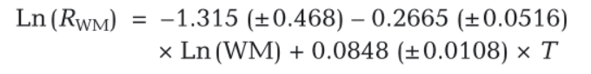

* Moto = a + b * RWM (model 3)
  + Expect a positive correlation of RWM with Moto.

## Methods

Otoliths are from cruises JR38, JR15004, JR16003 and JR177.

* *Electrona antarctica* n = 19.
* *E. carlsbergi* n = 17.
  + Some of these didn’t have body mass recorded, so were omitted from body mass analyses.
* *Gymnoscopelus braueri* n = 20.
* *G. nicholsi* n = 13.
* *Krefftichthys anderssoni* n = 20.
* *Protomyctophum bolini* n = 20.

For most otoliths, only the outer portion was sampled (100-200um depth), corresponding to the most recent part of the fish’s life. Where otoliths were too small to be milled (all *K. anderssoni* and some *P. bolini*), whole otoliths were crushed to obtain the sample.

### Moto

A mixing model was used to estimate the proportion of metabolic carbon in the blood,

M:

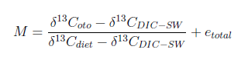

Where d13Coto is the d13C value of the fish's otolith, d13CDIC-SW is the value for d13C

of dissolved inorganic carbon (DIC) ingested by the fish through seawater, d13Cdiet

is the d13C of the diet, and etotal is the isotopic fractionation from DIC to blood,

blood to endolymph, and endolymph to otolith. For this study we assumed that etotal

was invariant across species, and that Moto values were directly proportional to the

percentage of metabolic carbon in the fish's blood (Chung et al., 2019).

d13CDIC-SW was set using catch location and corrected for the Suess effect (the decrease in d13C with time, due to anthropogenic carbon emissions) from the model by Tagliabue and Bopp (2008). d13Cdiet was set using muscle d13C from the same fish, minus the trophic enrichment factor for carbon from DeNiro and Epstein (1978). These parameters were allowed to vary across normal distributions, to give a range for each parameter.

For further information on the otolith proxy, see Chung et al. 2019 (<http://www.publish.csiro.au/mf/MF18317>)

### Temperature

d18O of otolith aragonite can be used to estimate the ambient temperature experienced

by a fish (Hoie et al., 2004, Thorrold et al., 1997). Experienced temperature (T) was

reconstructed using the following equation:



Where d18Ooto is the d18O of the otolith, d18OSW is the d18O of the ambient seawater,

and a and b are parameters, set according to Hoie et al. (2004). d18OSW was set using catch location and depth according to Schmidt et al. (1999).

## 

## 

## 

## Results

### Moto Among Species

* Expected values (intercepts of model 1) of Moto for species, at mean body mass and temperature (figure 1), from highest to lowest.
  + *E. antarctica* = 0.2115 ± 0.0177
  + *G. braueri* = 0.1999 ± 0.0181
  + *K. anderssoni* = 0.1938 ± 0.0183
  + *E. carlsbergi* = 0.1725 ± 0.0182
  + *P. bolini* = 0.1705 ± 0.183
  + *G. nicholsi* =0.1444 ± 0.0201
* *G. nicholsi* also had a variable intercept significantly less than zero (figure 4).
  + Suggests *G. nicholsi* has significantly lower Moto values than the other species.

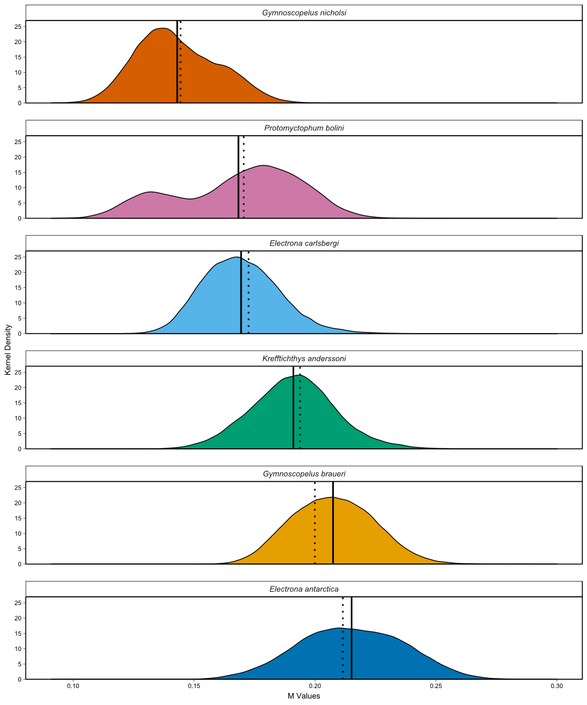

Figure 1 - Kernel density of posterior predictions of Moto for each individual, grouped by species (orange = *Gymnoscopelus nicholsi*, pink = *Protomyctophum bolini,* light blue = *Electrona carlsbergi*, green = *Krefftichthys anderssoni*, yellow = *G. braueri*, dark blue = *E. antarctica*). Solid lines indicate the mean Moto value of these posterior predictions for each species. Species expected values of Moto at mean body mass and temperature, according to model 1.

### 

### Body Mass and Temperature Among Species

* Mean individual experienced temperature ranged from -1.87 to 2.99°C.
* *G. braueri* experienced lowest temperatures, while *G. nicholsi* and *E. carlsbergi* experienced greatest temperatures.
* Posterior predictions of the scaling exponent for temperature (bT) are negative (figure 4).
  + Indicates a significant negative effect of temperature on Moto when body mass and species are accounted for (figure 2).

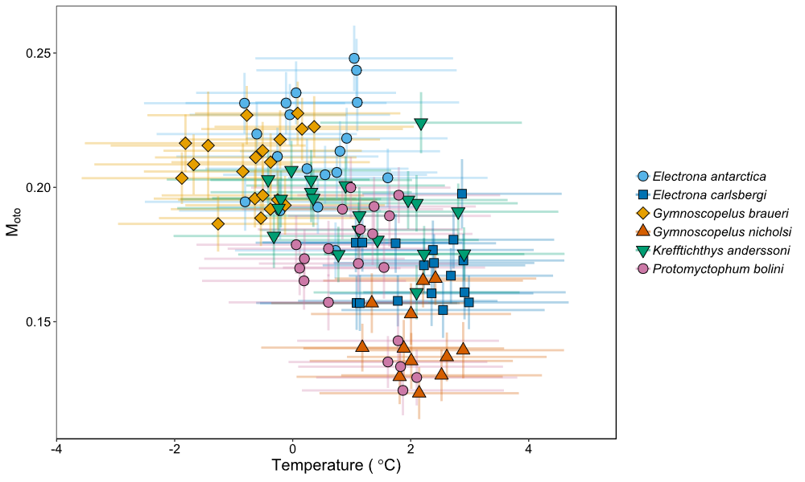

Figure 2 - Mean posterior predictions of Moto against mean reconstructed temperature (°C) for each individual. Bars indicate standard deviations of estimates.

* Body mass ranged from 0.5 to 38.7g wet weight.
* Posterior predictions of scaling exponent for body mass (bW) overlapped with zero (figure 4).
  + Indicates no significant effect of body mass on Moto when temperature and species are accounted for.

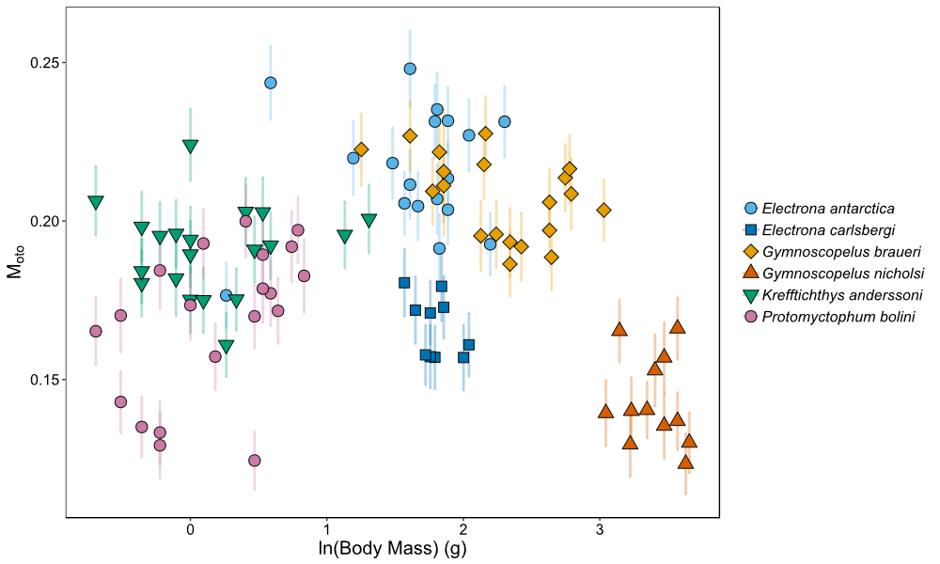

Figure 3 - Mean posterior predictions of Moto against mean log body mass (g) for each individual. Bars indicate standard deviations of estimates.

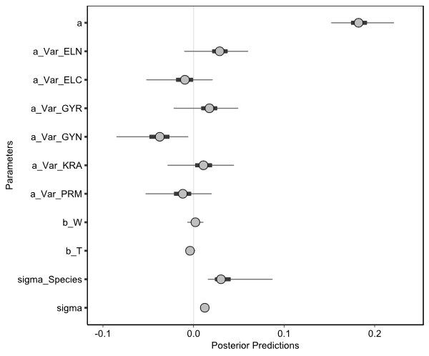

Figure 4 - Posterior predictions for model 1 (Moto = a + bW * W + bT * T + a_VarSpecies). Circles indicate the mean of the posterior predictions. Thick lines show the 50% posterior intervals, while thin lines show the 95% posterior intervals. ELN = *Electrona antarctica*, ELC = *E. carlsbergi*, GYR = *Gymnoscopelus braueri*, GYN = *G. nicholsi*, KRA = *Krefftichthys anderssoni* and PRM = *Protomyctophum bolini.* Sigma indicates error.

### 

### Body Mass and Temperature Within Species

* The only posterior predictions which did not overlap zero (significant) were bW for *G. braureri* and *P. bolini* (Figure 5 and 7).
* Negative bW for *G. braueri* (bW = -0.0159 ± 0.0089).
  + Negative effect of body mass on Moto when temperature accounted for.
  + Consistent with metabolic theory. Mass-specific metabolic rate (Moto) decreases with increasing body size.
* Positive bW for *P. bolini* (bW = 0.0262 ± 0.0124).
  + Positive effect of body mass on Moto when temperature accounted for.
  + Opposite to metabolic theory.
* No effect of temperature within species (Figure 6 and 7).

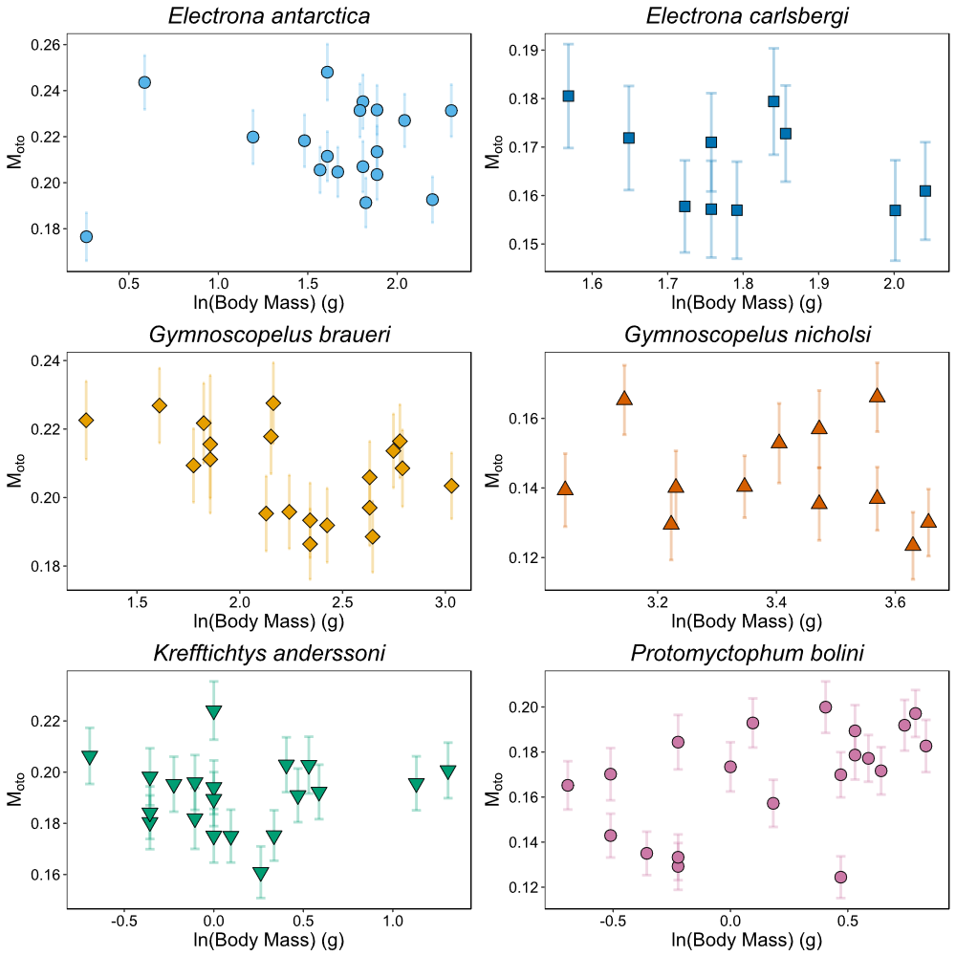

Figure 5: Mean posterior predictions of Moto against mean log body mass (g) for each individual.

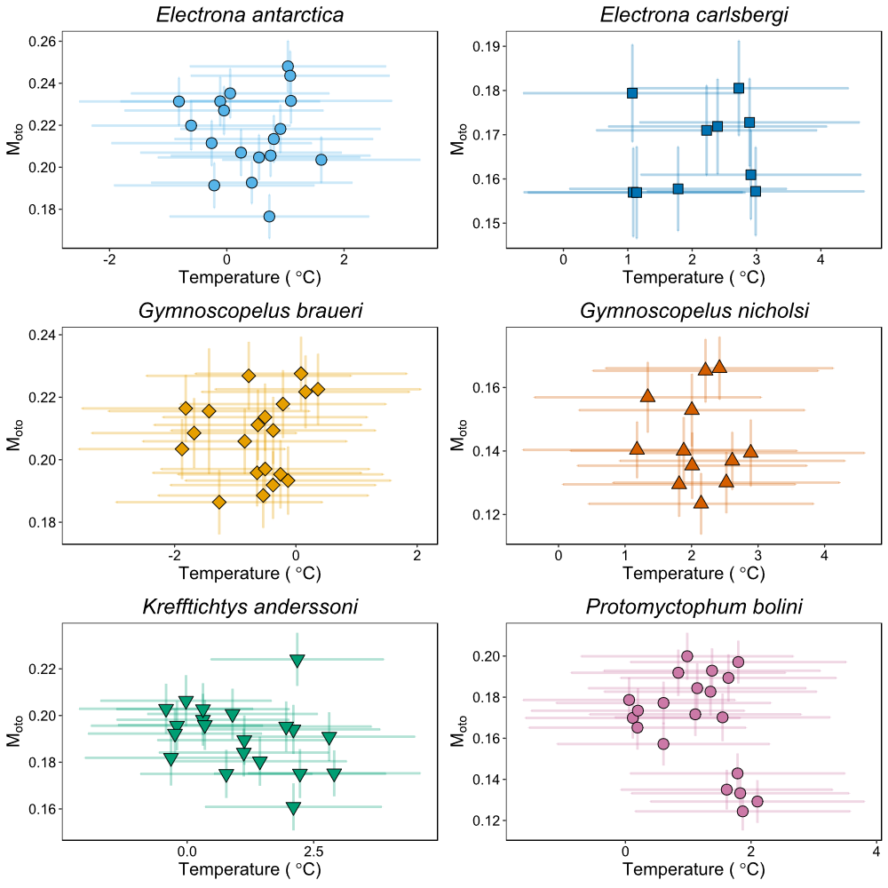

Figure 6: Mean posterior predictions of Moto against mean reconstructed temperature (°C) for each individual.

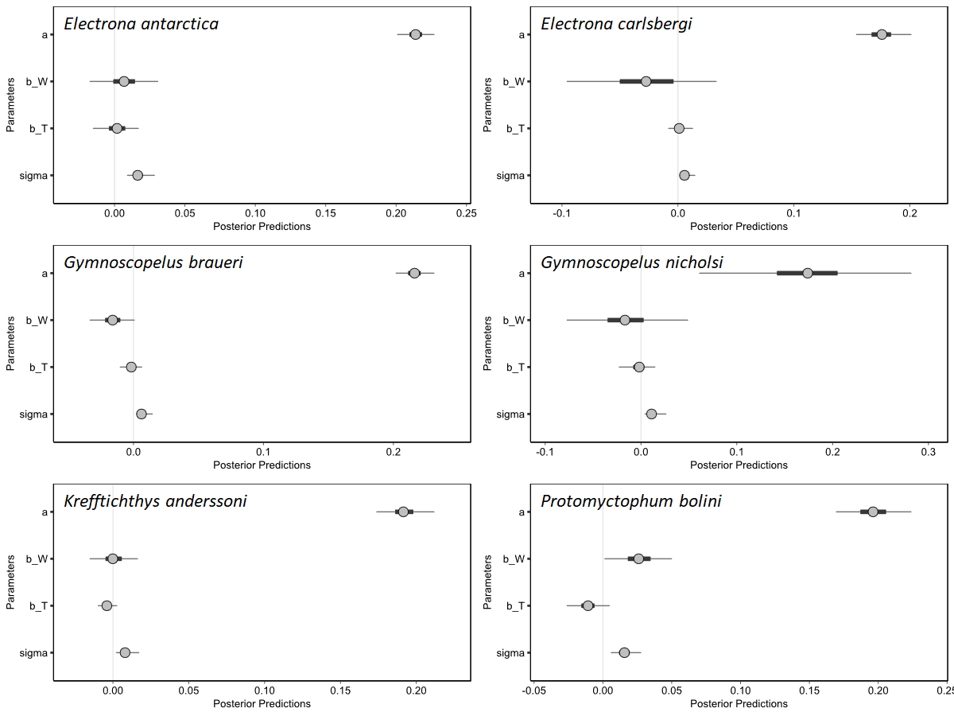

Figure 7: Posterior predictions for model 2 (Moto = a + bW * W + bT * T) within species. Circles indicate the mean of the posterior predictions. Thick lines show the 50% posterior intervals, while thin lines show the 95% posterior intervals. Sigma indicates error.

### 

### Comparison with Estimates from Belcher et al.2019

* Very large posterior intervals for resting metabolic rate calculated using the Belcher equation.
  + Due to uncertainty around equation parameters and propagation of uncertainty from reconstructed temperature estimates.
* Slight but significant negative correlation.
  + B = -0.0047 (± 0.0030).
  + Moto decreases with increasing estimated RWM.

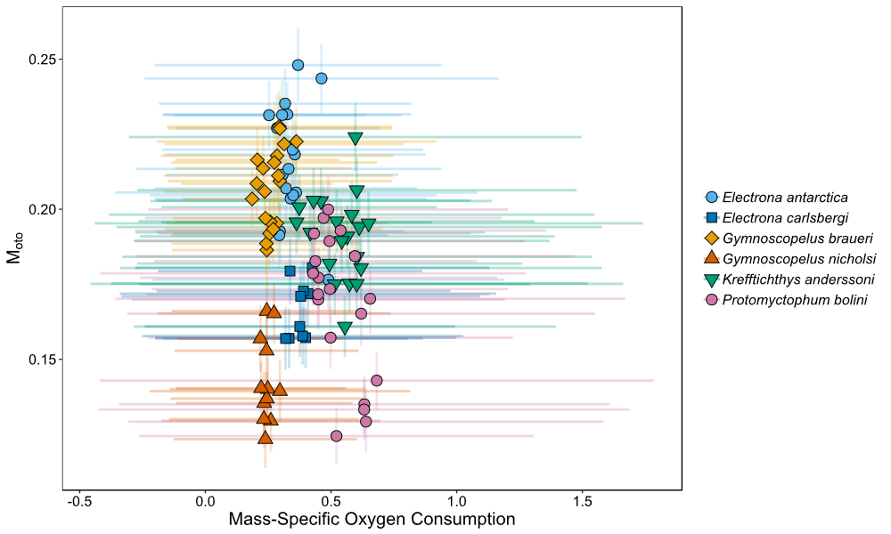

Figure 8: Moto and mass-specific resting metabolic rates, with standard deviation bars.

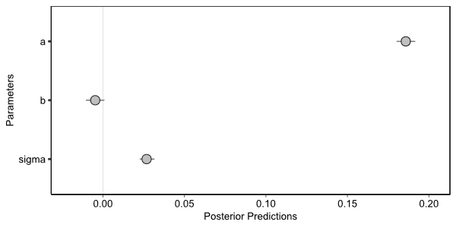

Figure 9: Posteriors predictions for model (Moto = a + b * RWM). Circles indicate the mean of the posterior predictions. Thick lines show the 50% posterior intervals, while thin lines show the 95% posterior intervals.

## Ideas/Discussion

### Species Differences

* High Moto species known to perform diel vertical migration (DVM), and have broad depth range (0-1000m).
  + *E. antartica, G. braueri, K. anderssoni* (Piatkowski et al. 1994, Collins et al. 2008, Saunders et al. 2014, 2015, Lourenco et al. 2017)*.*
  + Daily or near daily migrations by these species may increase metabolic costs.
* Low Moto species:
  + *E. carlsbergi* - seasonal changes in DVM. Mostly in upper 400m (Kozlov et al. 1991, Collins et al. 2008, 2012, Saunders et al. 2014).
  + *P. bolini* - some evidence of DVM. Restricted above 400m (Piatkowski et al. 1994, Pusch et al. 2004, Collins et al. 2012, Saunders et al. 2014, 2015).
  + *G. nicholsi* - nothing on DVM? Above 700m (Pusch et al. 2004, Saunders et al. 2015).
  + All sometimes caught down to 1000m (Piatkowski et al. 1994, Collins et al. 2008).
* Question: Do these species swim to migrate vertically, or do they use swim bladders, or another method of buoyancy control? Is this migration a reasonable explanation for the higher Moto values?
  + *E. antartica, G. braueri* and *G. nicholsi* only have residual swim bladders, so presumably they swim? Or can they use wax esters to regulate buoyancy?
  + *K. anderssoni, P. bolini* and *E. carlsbergi* all have well developed swim bladders.
* *G. nicholsi* may become benthopelagic in late adulthood.
  + Associated with less movement and lower metabolic rate compared to pelagic fishes (Killen et al. 2016).
  + May explain why their Moto values are significantly different.
* Question: Does this seem plausible? Is there anything else about *G. nicholsi* which might explain the significantly lower Moto?

### Apparent Negative Temperature Correlation

* Negative correlation of Moto and temperature may be an artefact.
* Two species with lower Moto values are more common in the northern Scotia Sea, where temperatures are warmer.
  + *P. bolini* and *E. carlsbergi* (Collins et al. 2008, 2012, Saunders et al, 2014, 2015).
    - *P. bolini* also sensitive to temperatures below 1.5C.
  + Above species do not complete life cycles within the Scotia Sea (Hulley 1981, Saunders et al. 2014) due to low temperatures.
    - Possibly also *G. nicholsi*?
  + May be at the lower end of the thermal range, inhibiting metabolic rates.
* Species with highest Moto values are found throughout the Scotia Sea.
  + *E. antarctica* and *G. braueri* (Saunders et al. 2014, 2015)*.*
  + Complete whole life cycle in the Scotia Sea.
  + May be living well within their thermal range, so better able to maintain higher metabolic rates.
* Question: Does this seem plausible?

### Within Species

* Body mass and temperature also not good for predicting Moto within myctophid species.
  + Except for body mass for *G. braueri* and *P. bolini.*
* *P. bolini* is contrary to metabolic theory.
  + Unclear why this is the case.
* Question: Any ideas about this?

### Negative Relationship with Predicted RMR

* Would expect Moto to increase with increasing predicted mass-specific RMR.
* Assuming Belcher equation is accurate, suggests that variables other than temperature and body mass have a larger effect on FMR.
* May also be issues in parameterising Belcher equation.
  + Electron transport system (ETS) is converted to respiration using ratios, which varied from study to study.
    - This uncertainty wasn’t incorporated.
  + Studies used had much greater temperature range (0.5 to 20 C) than was found in our study.
    - May overinflate the importance of temperature at small ranges.
* Question: Are these valid critiques of Belcher et al. 2019?
* **Take home message: species is the most useful variable in modelling Moto values.**
  + Due to ecology?
  + Body mass and temperature on the whole are not useful.

## 

## Preempted Questions

* **Can we convert Mototo oxygen consumption?**
  + Moto is related to oxygen consumption through the equation:

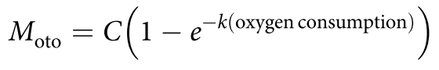

* + The upper bound (C) and decay constant (k), may be species specific, and at the moment, these terms have only been calculated for *Gadus morhua* (Chung et al. 2019). As such, we can’t confidently estimate oxygen consumption for myctophids at this time.
* **The relationship between Moto and oxygen consumption is not linear. Why have you treated it as linear in this study?**
  + The upper bound of this relationship is thought to only occur at very high metabolic rates, much higher than those that are experienced over time by wild fish. Below this upper bound, the relationship is linear for all intents and purposes.
* **Can I have a look at your data/code?**
  + Yes all of the data and code for this project is available on a private GitHub repository. It needs a bit of a tidy, but if you’d like to have a look at it please send me an email and I’ll give you access.

## Appendix: Notes on Bayesian Statistics

* All done in R 3.4.4.
* Moto calculated using MixSIAR (JAGS).
  + Uninformative priors.
  + 100,000 iterations.
  + 50,000 burn in.
  + 50 thinning parameter.
  + 3 chains.
* Temperature calculated using JAGS.
  + Informative priors (data from papers and cruise reports).
  + 100,000 iterations.
  + 50,000 burn in.
  + 50 thinning parameter.
  + 3 chains.
* Belcher equation calculated using JAGS.
  + Uninformative priors.
  + 100,000 iterations.
  + 50,000 burn in.
  + 50 thinning parameter.
  + 3 chains.
* Models run using Stan.
  + 3000 iterations.
  + 1500 warmup.
  + Uninformative priors.
  + Parameters z-scored before passing through model.